|  |  |
| --- | --- |
|  | H:\All Work Folders\T & D\Logos\UHS new Trust colour logo.jpg |

**Scientist Training Programme**

**(STP) OPEN DAY**

**TUESDAY 7th JANUARY 2020, 10am – 3pm**

Are you a science graduate with a 2:1 degree or higher or are you about to complete a science degree and want to train to be a Clinical Scientist in the NHS?

We offer a range of programmes across the disciplines and invite interested people to see our hospital and what we offer.

The programmes we hope to offer for September 2020 are:-

* Respiratory & sleep science
* Critical care science
* Gastrointestinal physiology
* Clinical immunology
* Radiotherapy physics
* Genomic counselling
* Bioinformatics (medical physics)

*(subject to confirmation of funding by Health Education England)*

The open day will include:-

* A general overview of the STP programme
* How UHS supports STP trainees to maximise their training
* Presentations by past and present UHS scientist trainees
* Tours of departments, where possible
* Stands including poster and departmental information with staff and student representation to answer questions on specific areas

For more information on the STP programme see:- [www.nshcs.org.uk](http://www.nshcs.org.uk)

To register for this open day email:- [HCSAHPeducation@uhs.nhs.uk](mailto:HCSAHPeducation@uhs.nhs.uk)

Closing date:- 12th December 2019

#UHSSTP20 Follow us on twitter @uhshcsahp

University Hospital Southampton NHS Foundation Trust, Tremona Road, Southampton, SO16 6YD

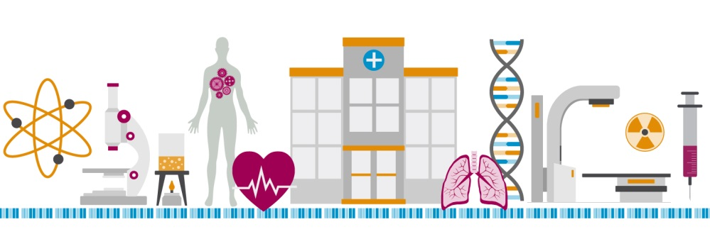

*Image supplied by the National School of Healthcare Science*