**Yearly timetable:** Adding in inductions (red), University teaching blocks (blue) and each rotations

**Example 3 Training plan: Genomics**



Planning for the year helps set the scene for trainee and secures agreements for rotations in your trust/local areas.



**Yearly timetable:** Years 2 and 3

* Mapping them out helps with workload pressures if you have multiple trainees (and multiple cohorts). They also need to be flexible as project and elective elements may affect this.
* Important to take into consideration the project milestones (Sept-Dec in year 2) that Universities require.



**Identifying Training Roles and responsibilities in your department:**

* Getting staff involved in the training of STPs helps spread the expertise and also helps deal with large trainee numbers or alleviate workload pressures.
* This also helps you to work collaboratively in making changes or adjusting to local or national factors (i.e curriculum updates/new specialities).

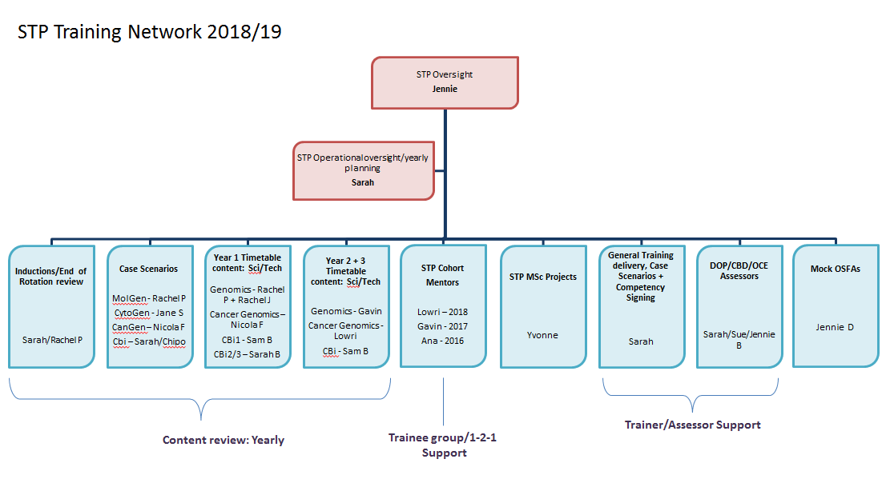

**Breakdown of Genomics (core) module**

Details learning outcomes and competencies with links to Curriculum library. It also details the assessments required of the module in this case they are pre-selected due to large number of trainees.



**Guide for trainees of which staff are suitably trained and can sign off competencies.**

Having a list of assessors may help spread the workload if there are a large number of trainees or the competency is relatively detailed. It also helps direct the trainees if you have multiple modules to coordinate.



**Mapping out what a standard rotation looks like**

* Work with your colleagues on the ground and map out all the essential experiences and learning situations.
* Having a standard timetable gives you something to work with when you first meet your trainee (internal or external). This can then be adapted depending on the trainee or for other factors. Not all rotations have or need to be this structured.

