Complaints Policy

Version: | Final agreed copy,  NSHCS Complaints Policy 2022 v.1
Ratified by: | NSHCS Senior Management Team
Date ratified: | 14/10/2022
Name and Title of originator/author(s): | Rita Garcha, Deputy Head of Programme Support  Anthony Hoswell, Professional Standards and Improvement Manager  NSHCS Policy and Procedures Committee
Name/Role of responsible person: | Prof Berne Ferry, Head of School
Date issued: | 14/10/2022
Review date: | 12 months from ratification
Target audience: | Any NSHCS stakeholders
Document History: | Version 1: Creation of Policy
Supporting guidance and documentation issued in support of the application of this policy

Document Status
This is a controlled document. Whilst this document may be printed, the electronic version posted on the National School of Healthcare Science (NSHCS) website is the controlled copy. Any printed copies of this document are not controlled.

As a controlled document, this document should not be saved onto local or network drives but should always be accessed from the NSHCS website. (https://nshcs.nhs.uk/publications)

This version is the only Complaints Policy recognised by NSHCS. This supersedes any current or previous localised policies, which will no longer be applicable and cannot be relied upon.

Executive Summary

This policy provides a means for persons or organisations that receive a service from the NSHCS or are affected by the services provided by the NSHCS, to raise a complaint.

A complaint is an expression of dissatisfaction about an act, omission, decision, or a service provided by us. A dissatisfaction may arise from the actions of a member of our staff, or from an area or programme of work that we are involved in. Complaints provide an opportunity to listen, learn and act on the feedback of our stakeholders.

In applying this policy, NSHCS will have due regard for the need to eliminate unlawful discrimination, promote equality of opportunity, and provide for good relations between people of diverse groups, in particular on the grounds of the following characteristics protected by the Equality Act (2010); age, disability, gender, gender reassignment, marriage and civil partnership, pregnancy and maternity, race, religion or belief, and sexual orientation.

Contents

Paragraph | Page
- Introduction | 4
- Purpose | 4
- Scope | 4
- Outcomes | 5
- Complainant Responsibilities | 5
- NSHCS Responsibilities | 5
- Complaints Panel | 7
- Access to the Complaints Policy | 7
- The Complaints Process | 8
- Equality Impact Assessment | 9
- Monitoring Compliance and Effectiveness | 10
12. Records Management | 10
13. Appendix 1. Process Flow Chart | 11
14. Appendix 2. The Complaints Form | 12

Introduction

This policy is to provide a means for persons or organisations that receive a service from the NSHCS or are affected by the services provided by the NSHCS, to raise a complaint about the work we do, about the service we provide, or about the actions of our staff.

The NSHCS aims to ensure a high standard of service is always provided, however; we recognise there may be occasions when a service or process can fall below the standards that we would expect. If this happens and you are not satisfied, then please follow the steps in this policy to raise a complaint.

The NSHCS takes complaints very seriously and will endeavour to learn lessons and improve or change processes where needed.

Purpose

The primary purpose of this policy is to provide any persons or organisations that receive a service from the NSHCS or are affected by the services provided by the NSHCS, with a mechanism to complain where they feel the NSHCS are not meeting the appropriate standards of service delivery or are not satisfied with the service provision.

Scope

This policy applies to persons or organisations that receive a service from the NSHCS or are affected by the services provided by the NSHCS.

The policy covers complaints about:
- the standard of the service we provide;
- the behaviour of our staff;
- any act or omission by the NSCHS that negatively affects our stakeholders.

The policy does not cover:
- matters that have already been fully investigated and closed through this complaints procedure;
- anonymous complaints;
- malicious, repetitive or vexatious complaints;
- complaints about access to information where procedures and remedies are set out in legislation, e.g., Freedom of Information Act, Data Protection Act;
- academic appeals, which should use the Academic Appeals Policy;
- matters relating to services that are not provided by the NSHCS.

Outcomes

The Complaints Policy can provide the following outcomes:
- the complaint is upheld in full;
- the complaint is upheld in part;
- the complaint is rejected;
- the complaint is withdrawn.

Where the complaint is upheld, either in part or in full, the NSHCS will communicate the reason(s) for the decision to the complainant and outline any actions that may be taken by the NSHCS to remedy the complaint and/or prevent a recurrence of the issues that led to the complaint.

Where the complaint is rejected, the NSHCS will communicate the reason(s) for the decision to the complainant.

Where the complaint is withdrawn, the NSHCS will close the complaint and communicate this to the complainant. The NSHCS reserves the right to continue to act upon the information received from the withdrawn complaint where it feels there is a justification to do so, such as to identify any actions that may be taken by the NSHCS to prevent a recurrence of the issues that led to the complaint.

Where the complainant is not satisfied with the outcome of the complaint as outlined in sections 4.1 – 4.3, they may request to appeal the decision. This must be done in writing to the Head of School using the prescribed Appeals Form.

Complainants Responsibilities

To fully complete the prescribed Complaints Form to log the complaint and communicate it to the NSHCS, ensuring that you include:
- a clear and detailed description of the nature of the complaint;
- accompanying evidence supporting the complaint;
- your contact details, including an email address.

To provide factual and true information pertaining to the complaint.

To engage with the policy in a timely manner.

To allow the complaint to be processed through the appropriate stages and within the required timeframe before expecting an outcome or response.

To behave appropriately and reasonably, and where applicable, in line with the expectations of the NHS Constitution values and behaviours, in all aspects relating to this policy.

NSHCS Responsibilities

To respond to complaints received via the prescribed Complaints Form in a timely manner and ensure the complainant has a record of the complaint.

To follow the Complaints Policy ensuring that each complaint is processed through the appropriate stages within the required timeframe.

To ensure that complainants are provided with necessary guidance and support on the use of this policy and are aware of the stages and timeframes that apply to the complaints process.

To ensure that a relationship of mutual trust and respect is developed between the complainant and the NSHCS, where matters are dealt with respectfully and sensitively.

To ensure that complaints are assessed consistently in a fair and equitable manner.

To behave appropriately and in line with the NHS Constitution values and behaviours in all aspects relating to this policy.

To manage your complaint and all accompanying evidence, including statements and records, confidentially, as far as is reasonably practicable in facilitating a fair and thorough investigation. In doing so we will balance the following:
- the need for an open and fair investigation;
- the need to undertake appropriate remedial action;
- the need to report the outcomes of our investigations appropriately;
- the need to undertake actions to improve our processes and service provision.

In executing the requirements of 6.7, information relating to your complaint may be shared with others within the NSHCS.

In all cases your personal data will be handled according to the requirements of the Data Protection Act 2018 and the General Data Protection Regulations (GDPR)

Complaints Investigation

Complaints will be investigated by an investigation officer, appointed from within the NSHCS.

The investigating officer will be appointed and overseen by a Complaints Panel, which will ordinarily consist of the Director of Operations and the Professional Standards and Improvement Manager, or other persons of similar seniority from within the NSHCS that have not been involved in the matter from which the complaint has arisen.

The investigating officer will be appointed based on having appropriate skills to investigate complaints.

The investigating officer will have the remit and authority to call on any members of NSHCS staff and partners to provide evidence to the panel, either verbally or in writing. This may include the gathering and verification of evidence, further consultation with involved parties, requests for additional information from the trainee/apprentice, and escalation (for example, to the Head of School) to obtain the necessary authority to proceed.

The investigating officer will report their findings to the Complaints Panel.

The Complaints Panel will be responsible for determining what actions are to be taken by the NSHCS in response to the findings of the investigating officer.

The Complaints Panel will be responsible for communicating these actions to the appropriate administrative functions of the NSHCS and through these to the complainant.

Access to the Complaints Policy

Those wishing to raise a complaint with the NSHCS must do so using the prescribed Complaints Form.

Any complaints received which do not use the prescribed form will not be processed. We will respond requesting that the Complaint Form is completed before your complaint can be acknowledged and the complaints process initiated in line with this policy.

If you require any assistance when completing the form, please contact us using the following email address and we will be able to assist. NSHCS@hee.nhs.uk

Complaints should be made in a timely manner and should be made as soon as reasonably practicable. In most cases this will mean that complaints will only be considered where they are made within three months of the matters that led to the complaint occurring.

In all cases, complaints of a historic nature will only be considered in line with the provisions of the Limitations Act 1980.

The Complaints Process

The complaints process can be broken down into four stages.

Stage One – the complaints process begins when a complainant completes the Complaints Form and submits it to the NSHCS. Following receipt of a completed Complaint Form and accompanying evidence, the NSHCS will acknowledge receipt and confirm that the complaints process has been initiated. This will ordinarily occur within two working days of receipt of the Complaints Form. A reference number will be provided at this stage and should be quoted in all future correspondence relating to the complaint.

Where evidence is not included or is unsuitable the NSHCS will request additional evidence is provided at this stage. This request will ordinarily be made within two working days of receipt of the Complaints Form.

Stage Two – the NSHCS will consider the complaint and accompanying evidence and confirm whether it falls within the scope of the Complaints Policy. This will ordinarily occur within five working days of receipt of the Complaints Form. Where the complaint is outside of the scope of the policy the reason(s) for this will be communicated to the complainant and the complaint will be closed at this stage.

Stage Three – where the complaint is within the scope of the policy the NSHCS will appoint an investigating panel, as described in section 7, and will communicate to the complainant that the complaint is being investigated.

In appointing an investigating panel, the NSHCS will ensure that the membership is adequately supported to undertake an investigation in a timely and effective manner.

In most cases the expectation will be that a complaint investigation will be completed within twenty working days of the start of stage three. Where additional time is required, this will be communicated to the complainant.

Where a complaint is particularly complex there may be a need to consult more widely or gather additional evidence. In such cases more time may be required to properly investigate. A guiding principle will be that the panel will conduct their investigation in a timely and effective manner and report their outcomes at the earliest opportunity.

Where additional evidence is required, the Complaints Panel will contact the complainant at the earliest opportunity and allow no more than twenty working days for the submission of any additional evidence.

Stage Four – The investigating panel’s findings will be summarised, with the complaint outcome and rationale communicated to the complainant.

Stage four is the final stage of the complaints process and there is no further avenue for pursuing a complaint with the NSHCS.

Where the complaint is upheld, either in part or in full, the NSHCS will communicate the reason(s) for the decision taken to the complainant and outline any actions that may be taken by the NSHCS to remedy the complaint and/or prevent a recurrence of the issues that led to the complaint.

Where the complaint is rejected, the NSHCS will communicate the reason(s) for the decision taken to the complainant.

You may withdraw your complaint at any stage, up to and including stage four.

Where the complaint is withdrawn, the NSHCS will close the complaint and communicate this to the complainant. The NSHCS reserves the right to continue to act upon the information received from the withdrawn complaint where it feels there is a justification to do so, such as to identify any actions that may be taken by the NSHCS to prevent a recurrence of the issues that led to the complaint.

The NSHCS expects that most complaints would be fully resolved within stages one - four. Where the complainant is not satisfied with the outcome of the complaints process, they may request to appeal the decision. This must be done by following the NSHCS Appeals Policy.

A request to appeal the Complaints Panel decision can only be made on the following grounds:
- that the procedures described in paragraphs 9.1 – 9.10 were not followed;
- that the outcome of the process is not reasonable;
- that significant new evidence has come to light that could not have reasonably been presented during the initial complaint.

The procedure described in points 9.2 – 9.17 is summarised on the process flow chart found at Appendix 1.

Equality Impact Assessment

The NSHCS and HEE give due regard to the need to eliminate discrimination and promote equality of opportunity for all when making policy decisions and implementing this policy.

This policy has been developed with input from the NSHCS Equality, Diversity and Inclusion Committee and an accompanying Equality Impact Assessment has been produced.

Monitoring Compliance and Effectiveness

The NSHCS is responsible for recording and monitoring information relating to the application of this policy.

The NSHCS Policy and Procedures Committee is responsible for this policy and will review its compliance and effectiveness.

Anonymised data relating to the outcomes of this policy will be available to the NSHCS Equality, Diversity and Inclusion Committee and reviewed to ensure there are no underlying themes relating to equality that suggest any organisational bias.

The policy may be periodically amended to ensure it remains effective, relevant, and compliant with current legislation.

Records Management

All records must be compliant with HEE’s Records Management Policy.

Records should be treated as confidential and retained no longer than necessary in accordance with the relevant Data Protection legislation. All records must be maintained electronically. Please refer to HEE’s Records Management Policy for further information.

End of document

Appendix 1. Process Flow Chart for the Complaints Policy

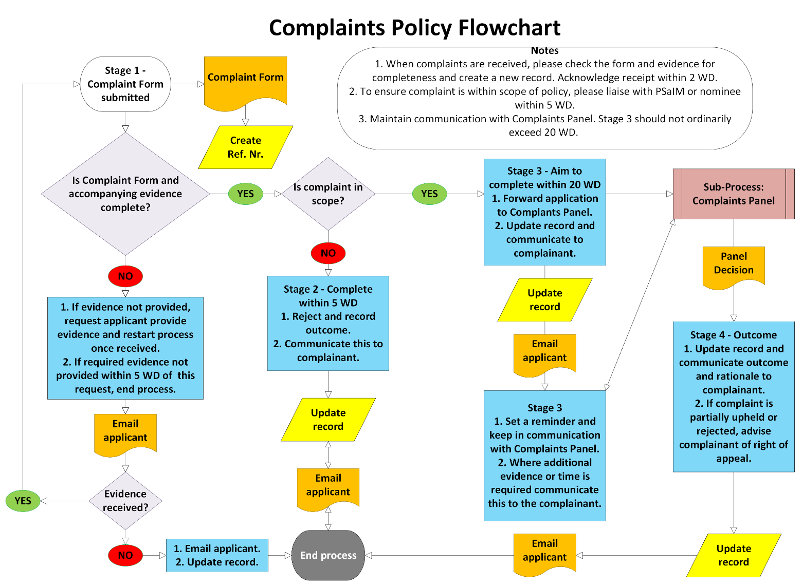

Appendix 2. Complaints form

Name of Complainant:
Email Address:
Telephone number:
(Should we need to contact you to discuss the matter)
Date:

Describe in detail the reason for your complaint

Detail any evidence or correspondence that relates to your complaint and attach it. Please ensure attachments are appropriately referenced.

For Office use only.
Reference number:

Any other information:

