Mitigating Circumstances Policy

Version: | Final agreed copy,  NSHCS Mitigating Circumstances Policy 2022 v.1
Ratified by: | NSHCS Senior Management Team
Date ratified: | 14/10/2022
Name and Title of originator/author(s): | Stephen Tipping, Deputy Head of Assessment  Anthony Hoswell, Professional Standards and Improvement Manager  NSHCS Policy and Procedures Committee
Name of responsible Director: | Professor Berne Ferry,  Head of School
Date issued: | 14/10/2022
Review date: | Annually in January/February for launch prior to the summer assessments.
Target audience: | Trainees of the National School of Healthcare Science
Document History: | Version 1: Creation of Policy
Supporting guidance and documentation issued in support of the application of this policy

Document Status
This is a controlled document. Whilst this document may be printed, the electronic version posted on the National School of Healthcare Science (NSHCS) website is the controlled copy. Any printed copies of this document are not controlled.

As a controlled document, this document should not be saved onto local or network drives but should always be accessed from the NSHCS website. (https://nshcs.nhs.uk/publications)

This version is the only Mitigating Circumstances Policy recognised by NSHCS. This supersedes any current or previous localised policies, which will no longer be applicable and cannot be relied upon.

Executive Summary

The Mitigating Circumstances Policy is part of a suite of policies designed to support fair and equitable final assessment.

Mitigating circumstances are defined as significant unforeseen and/or unavoidable events or issues that are more likely than not to have caused you detriment in your final assessment.

The Mitigating Circumstances Policy allows you to raise matters in a timely way that you believe would affect your ability to participate in your final assessment, or your ability to demonstrate your understanding, competence, or readiness to practice. In response, the NSHCS aims to take proportionate evidence-based actions to provide a fair and equitable assessment experience. This means we will try to remove or reduce aspects that would make the assessment inequitable, without creating an unfair advantage for you.

In applying this policy, NSHCS will have due regard for the need to eliminate unlawful discrimination, promote equality of opportunity, and provide for good relations between people of diverse groups, in particular on the grounds of the following characteristics protected by the Equality Act (2010); age, disability, gender, gender reassignment, marriage and civil partnership, pregnancy and maternity, race, religion or belief, and sexual orientation.

If you need support to use this policy, please contact the NSHCS Assessment Team (nshcs.assessment@hee.nhs.uk).

Contents

Paragraph | Page
- Introduction | 5
- Purpose | 5
- Scope | 5
- Outcomes | 6
- Your Responsibilities | 7
- NSHCS Responsibilities | 7
- Mitigating Circumstances Panel | 8
- Access to the Mitigating Circumstances Policy | 8
- The Mitigating Circumstances Process | 9
- Equality Impact Assessment | 9
- Monitoring Compliance and Effectiveness | 9
12. Records Management | 10
13. Appendix 1. Process Flow Chart | 11
14. Appendix 2. The Mitigating Circumstances Application Form | 12

Introduction

This policy is part of a suite of policies designed to provide you with a fair and equitable experience of NSHCS assessment decisions.

Through this policy we aim to take proportionate evidence-based actions to provide a fair and equitable assessment experience. This means we will try to remove or reduce aspects that would make the assessment inequitable, without creating an unfair advantage for you. The remedies or solutions we offer must be permitted by the policies and regulations of the final assessment, and the time and resources available.

You may apply for mitigating circumstances if you reasonably believe that there are significant unforeseen and unavoidable issues that are likely to affect your participation in a final assessment, or that would affect your ability to demonstrate understanding, competence, or readiness to practice.

If you apply for mitigating circumstances in good faith, you will not be treated less favourably, or suffer any disadvantage, than if you had not made the application.

You may be subject to disciplinary action if your mitigating circumstances application includes false or misleading statements, information, or evidence, which seek to create an unfair advantage.

Mitigating circumstances applications are not always upheld. We base our decisions on the evidence you provide, and which we could independently verify if necessary.

Purpose

This purpose of this policy is to provide a way for you to apply for reasonable and proportionate arrangements for final assessments in order to remove disadvantage, or to seek consideration from a Ratification Board if you have unavoidably suffered significant detriment during a final assessment.

Scope

This policy allows the NSHCS to consider applications for mitigating circumstances on the following grounds:
- unforeseen and/or unavoidable health issues affecting you;
- unforeseen and/or unavoidable health issues or caring responsibilities of a close relative or dependent;
- unforeseen and/or unavoidable disruption, where it was not possible for you to reach the venue of the assessment, or otherwise participate in the assessment, or which have caused significant disruption to the assessment;
- other significant unforeseen and/or unavoidable issues affecting your final assessment which have caused significant disruption to the assessment.

Applications for mitigating circumstances will not be considered for any other reasons other than those outlined in paragraph 3.1. All applications must use the correct process as described in this policy.

This policy applies to final assessments administered by the National School of Healthcare Science for all programmes other than apprenticeships. Apprenticeship programmes are covered by a separate set of policies.

Mitigating circumstances are defined as significant unforeseen and/or unavoidable events or issues that are more likely than not to have caused you detriment in your final assessment.

Mitigating circumstances arrangements must be proportionate and permitted within NSHCS policies and cannot be used to create an advantage for you; unless that advantage is an indirect and unavoidable consequence of the arrangement.

Outcomes

Where your application is unclear, or is not sufficiently supported by evidence, we may contact you to provide additional information by a deadline.

The Mitigating Circumstances Policy can provide the following outcomes:
- the application is upheld in full;
- the application is upheld in part;
- the application is not upheld;
- the application is withdrawn.

Where the application is upheld, either in part or in full, the NSHCS will communicate the reason(s) for the decision to you and outline any actions that may be taken by the NSHCS to provide remedy.

Where the application is not upheld, the NSHCS will communicate the reason(s) for the decision to you.

Where the application is withdrawn, the NSHCS will close the application and communicate this to you.

If you are not satisfied with the outcome of the application, then you may make an appeal. This must be done using the prescribed Appeals Form and you are referred to the NSHCS Appeals Policy for more information.

Your Responsibilities

To make an accurate mitigating circumstances application under this policy following the process outlined below. You must include verifiable written evidence, wherever possible.

Where appropriate, to discuss a mitigating circumstances application with your training officer or NSHCS Training Programme Director. Your training officer may provide a statement and evidence to support your application. You may also contact a member of the NSHCS Assessment team for advice on using this policy.

To behave appropriately and reasonably, in line with the expectations of the NHS Constitution values and behaviours, in all aspects relating to this policy.

If your application is considered to include false or misleading statements, information, or evidence, which seek to create an unfair advantage, the NSHCS may take appropriate action, for example:
- removing one of your available opportunities to sit/resit the assessment;
- reporting your actions to relevant external bodies;
- other disciplinary action, such as removing you from the programme.

NSHCS Responsibilities

To follow the Mitigating Circumstances Policy ensuring that each application is processed through the appropriate stages within the required timeframe.

To ensure that you are provided with necessary guidance and support on the use of this policy and are aware of the stages and timeframes that apply to the process.

To ensure that a relationship of mutual trust and respect is developed between the applicant and the NSHCS, where matters are dealt with respectfully and sensitively.

To behave appropriately and in line with the NHS Constitution values and behaviours in all aspects relating to this policy.

In all cases your personal data will be handled according to the requirements of the Data Protection Act 2018 and the General Data Protection Regulations (GDPR).

Mitigating Circumstances Panel

Requests for mitigating circumstances will be considered by a Mitigating Circumstances Panel.

The Mitigating Circumstances Panel will ordinarily be appointed by the Head of Assessment, or their nominee.

The Mitigating Circumstances Panel will be appointed based on having the appropriate skills to undertake the role.

The Mitigating Circumstances Panel will convene regularly, as and when required, prior to and following the NSHCS final assessments, to consider applications and evidence.

The panel will ordinarily include at least one lay member.

Access to the Mitigating Circumstances Policy

Those wishing to apply for mitigating circumstances must do so using the prescribed Mitigating Circumstances Form.

Any applications received which do not use the prescribed form will not be processed. We will respond requesting that the Mitigating Circumstances Form is completed before your application can be processed in line with this policy.

If you require any assistance when completing the form, please contact us using the following email address and we will be able to assist nshcs.assessment@hee.nhs.uk

You are required to make a mitigating circumstances application at the earliest reasonable opportunity prior to the relevant assessment, or within five working days following the assessment.

You may make more than one mitigating circumstances application for the same assessment only if:
- a significant change has occurred which would make an agreed mitigating circumstances adjustment less effective, and this would make the assessment experience inequitable;
- new evidence relating to the previous application has subsequently come to light which could not reasonably have been provided before.

The Mitigating Circumstances Process

The process described in this section is summarised on the flowchart found at Appendix 1.

Applications must be made in a timely manner. You are required to make a mitigating circumstances application at the earliest reasonable opportunity prior to the relevant assessment, or within five working days following the assessment.

Applications made more than five working days after the assessment deadline will not be considered and cannot be applied retrospectively, unless the criteria for applying for mitigating circumstances were such that it would not be reasonably practicable to apply within this deadline. In such cases, a late application will only be considered at the sole discretion of the Head of School, or their nominee.

The Mitigating Circumstances Panel considers applications regularly, as and when required, in the period before and after final assessments. The panel will consider your application and accompanying evidence and will normally respond to your application within ten working days of convening. Complex applications may take longer, and in this case you will be advised of a revised timescale.

You may be asked to provide further information or evidence before or following the Mitigating Circumstances Panel. If possible, we will give you five working days to provide additional material; however, this may not always be possible. You must provide any requested material by the deadline we specify or provide a written explanation why additional evidence or evidence cannot be provided.

Equality Impact Assessment

The NSHCS and HEE give due regard to the need to eliminate discrimination and promote equality of opportunity for all when making policy decisions and implementing this policy.

This policy has been developed with input from the NSHCS Equality, Diversity and Inclusion Committee and an accompanying Equality Impact Assessment has been produced.

Monitoring Compliance and Effectiveness

The NSHCS is responsible for recording and monitoring information relating to the application of this policy.

The NSHCS Policy and Procedures Committee is responsible for this policy and will review its compliance and effectiveness.

Anonymised data relating to the outcomes of this policy will be available to the NSHCS Equality, Diversity and Inclusion Committee and reviewed to ensure there are no underlying themes relating to equality that suggest any organisational bias.

The policy may be periodically amended to ensure it remains effective, relevant, and compliant with current legislation.

Records Management

All records must be compliant with HEE’s Records Management Policy.

Records should be treated as confidential and retained no longer than necessary in accordance with the relevant Data Protection legislation. All records must be maintained electronically. Please refer to HEE’s Records Management Policy for further information.

End of document
Appendix 1. Mitigating Circumstances Flowchart

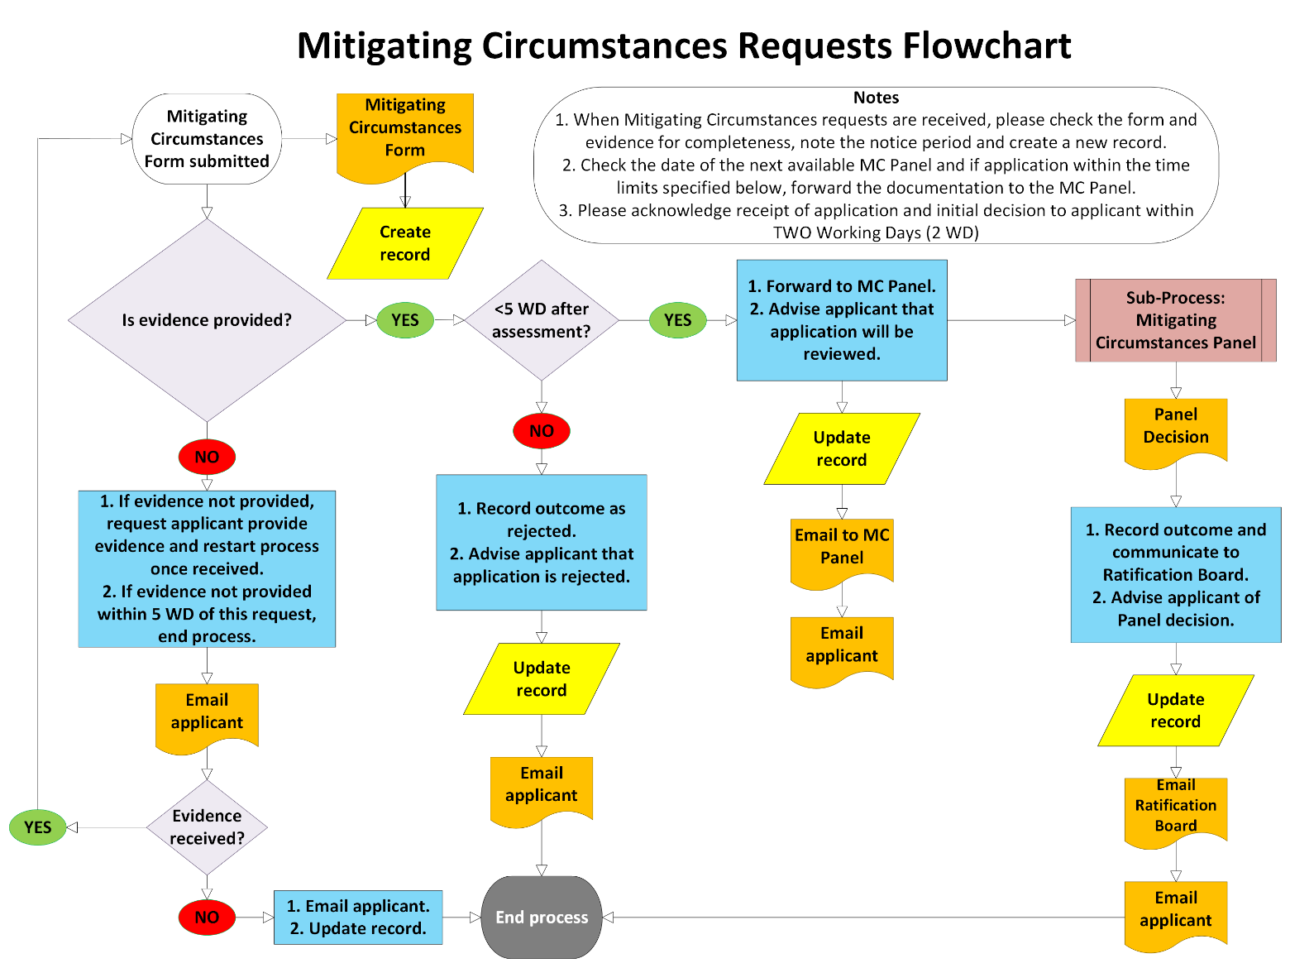
Appendix 2. Mitigating Circumstances Form

Application for mitigating circumstances

Applications for mitigating circumstances must be using this form. Applications should be made before published deadlines; applications made after a final assessment will not be considered.

Completed forms must be sent to the Programme Office inbox NSHCS@hee.nhs.uk and include the phrase MITIGATING CIRCUMSTANCES APPLICATION in the subject line.

Trainees should retain a copy of this form and supporting evidence.

Trainee name
Trainee number
Specialism
Email address
Phone number
Workplace
Training officer

Programme and final assessment your mitigating circumstances application relates to

Which NSHCS programme are you on?
Are you on a break from training?
Date of your final assessment:
If you previously applied for mitigating circumstances for this assessment, please give details.
Have you also applied for reasonable adjustments for this assessment?

Please provide a numbered list of evidence to support your mitigating circumstances application in the box below. Evidence should be attached to the email used to make your application, please include your evidence numbers in the file names of your evidence (e.g., Doctors Note_7). Further rows can be added if necessary.

Evidence No. | Filename
1
2
3
4
5
6
7

For each ground of your mitigating circumstances application please provide a brief supporting statement; evidence should be cited using evidence list numbering list (e.g., Doctors Note_7 p.2 para. 3). If particular grounds do not apply, please indicate NONE in the corresponding supporting statement box.

Grounds for your application | Supporting statement
Health or medical issues affecting you
Health or medical issues affecting a close relative or dependent
Unforeseen and unavoidable disruption affecting ability to attend or participate in the assessment
Other unforeseen and unavoidable issues affecting the assessment

Please clearly describe the impact on your final assessment and how each outcome you are seeking would help to provide an equitable assessment experience.

Grounds for your application | Please describe the impact of each part of your application on your final assessment and clearly explain how each outcome you are seeking would help to produce an equitable assessment experience.

Please sign to indicate that you believe that statements and evidence in your mitigating circumstances application are true, and not misleading or seeking unfair advantage.

Signed:

Date:

