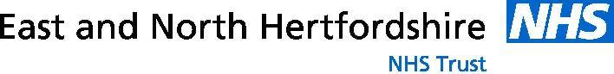

Scientist Training Programme (STP) Open Day

Application Form

Wednesday 11th January 2023, 15:00 to 18:00

Please complete the information below and email back by 4th January 2023 to:-

debbie.baker15@nhs.net

Personal information
Full name:
Mobile:
Email:
Candidates should have or be currently enrolled in a degree in physics, maths, engineering or a related discipline
University:
Programme:
Under or postgraduate:
Please indicate your main areas of interest
1st |  |  | 2nd

These are the areas we are hoping to offer in September 2023 intake.

- Radiotherapy Physics
- Nuclear Medicine
- Radiation Safety and Diagnostic Radiology
- Imaging with non-Ionising Radiation

