Appeals Policy

Version: | Final agreed copy,  NSHCS Appeals Policy 2022 v.1
Ratified by: | NSHCS Senior Management Team
Date ratified: | 14/10/2022
Name and Title of originator/author(s): | Anthony Hoswell, Professional Standards and Improvement Manager  NSHCS Policy and Procedures Committee
Name/Role of responsible person: | Prof Berne Ferry, Head of School
Date issued: | 14/10/2022
Review date: | 12 months from ratification
Target audience: | Any NSHCS stakeholders
Document History: | Version 1: Creation of Policy
Supporting guidance and documentation issued in support of the application of this policy

Document Status
This is a controlled document. Whilst this document may be printed, the electronic version posted on the National School of Healthcare Science (NSHCS) website is the controlled copy. Any printed copies of this document are not controlled.

As a controlled document, this document should not be saved onto local or network drives but should always be accessed from the NSHCS website. (https://nshcs.nhs.uk/publications)

This version is the only version recognised by NSHCS. This supersedes any current or previous localised policies, which will no longer be applicable and cannot be relied upon.

Executive Summary

This policy provides a means for persons or organisations that receive a service from the NSHCS or are affected by the services provided by the NSHCS, to appeal the outcome of an NSHCS process, except for academic decisions which are dealt with separately by the Academic Appeals Policy.

An appeal is defined as a request to change an outcome of an NSHCS process related to any act, omission, decision, or a service provided by NSHCS. Appeals provide an opportunity to listen, learn and act on the feedback of our stakeholders. An appeal differs from a complaint, in that a complaint may be related to a process, whereas an appeal is related to the outcome of the process. Complaints to NSHCS should follows the NSHCS Complaints Policy.

In applying this policy, NSHCS will have due regard for the need to eliminate unlawful discrimination, promote equality of opportunity, and provide for good relations between people of diverse groups, in particular on the grounds of the following characteristics protected by the Equality Act (2010); age, disability, gender, gender reassignment, marriage and civil partnership, pregnancy and maternity, race, religion or belief, and sexual orientation.

Contents

Paragraph | Page
- Introduction | 4
- Purpose | 4
- Scope | 4
- Outcomes | 5
- Your Responsibilities | 5
- NSHCS Responsibilities | 5
- Appeals Panel | 7
- Access to the Appeals Policy | 7
- The Appeals Process | 8
- Equality Impact Assessment | 9
- Monitoring Compliance and Effectiveness | 9
12. Records Management | 10
13. Appendix 1. Process Flow Chart | 11
14. Appendix 2. The Appeals Form | 13

Introduction

This policy is to provide a means for persons or organisations that receive a service from the NSHCS or are affected by the services provided by the NSHCS, to appeal against an outcome which is related to the work we do, the service we provide, or the actions of our staff, but which is not related to an academic decision.

The NSHCS aims to ensure a high standard of service is always provided and uses its policies to reach outcomes that are fair and equitable, however; we recognise there may be occasions when the outcome of a service or process is not satisfactory and/or does not appear to be fair or equitable to the recipient. If this happens and you are not satisfied, then please follow the steps in this policy to appeal.

The NSHCS will review all appeals and will endeavour to learn lessons and improve or change processes where needed.

Purpose

The primary purpose of this policy is to provide any persons or organisations that receive a service from the NSHCS or are affected by the services provided by the NSHCS with a mechanism to appeal against the outcome of a process, where they feel that the outcome is unfair or inequitable.

Scope

This policy applies to persons or organisations that receive a service from the NSHCS or are affected by the services provided by the NSHCS.

The policy covers appeals about:
- the outcomes of the service we provide;
- any act or omission by the NSCHS which results in an outcome that negatively affects our stakeholders.

The policy does not cover:
- complaints relating to process, which should use the Complaints Policy;
- academic appeals, which should use the Academic Appeals Policy;
- matters relating to services that are not provided by the NSHCS.

Outcomes

The Appeals Policy can provide the following outcomes:
- the appeal is upheld in full;
- the appeal is upheld in part;
- the appeal is rejected;
- the appeal is withdrawn.

Where the appeal is upheld, either in part or in full, the NSHCS will communicate the reason(s) for the decision to the applicant and outline any actions that may be taken by the NSHCS to remedy the situation and/or prevent a recurrence of the issues that led to the appeal.

Where the appeal is rejected, the NSHCS will communicate the reason(s) for the decision to the applicant.

Where the appeal is withdrawn, the NSHCS will close the appeal and communicate this to the applicant. The NSHCS reserves the right to continue to act upon the information received from the withdrawn appeal where it feels there is a justification to do so, such as to identify any actions that may be taken by the NSHCS to prevent a recurrence of the issues that led to the appeal.

The appeal process is the final mechanism with which to challenge an outcome. Where the applicant is not satisfied with the outcome of the appeal as outlined in sections 4.1 – 4.3, there is no further route to challenge this decision within the NSHCS.

Your Responsibilities

To fully complete the prescribed Appeals Form to initiate an appeal and communicate it to the NSHCS, ensuring that you include:
- a clear and detailed description of the nature of the appeal;
- accompanying evidence supporting the appeal;
- your contact details, including an email address.

To provide factual and true information pertaining to the appeal.

To engage with the policy in a timely manner.

To allow the appeal to be processed through the appropriate stages and within the required timeframe before expecting an outcome or response.

To behave appropriately and reasonably, and where applicable, in line with the expectations of the NHS Constitution values and behaviours, in all aspects relating to this policy.

NSHCS Responsibilities

To respond to appeals received via the prescribed Appeals Form in a timely manner and ensure the applicant has a record of the appeal.

To follow the Appeals Policy ensuring that each appeal is processed through the appropriate stages within the required timeframe.

To ensure that applicants are provided with necessary guidance and support on the use of this policy and are aware of the stages and timeframes that apply to the appeals process.

To ensure that a relationship of mutual trust and respect is developed between the applicant and the NSHCS, where matters are dealt with respectfully and sensitively.

To ensure that appeals are assessed consistently in a fair and equitable manner.

To behave appropriately and in line with the NHS Constitution values and behaviours in all aspects relating to this policy.

To manage the appeal and all accompanying evidence, including statements and records, confidentially as far as is reasonably practicable in facilitating a fair and thorough investigation. In doing so we will balance the following:
- the need for an open and fair investigation;
- the need to undertake appropriate remedial action;
- the need to report the outcomes of our investigations appropriately;
- the need to undertake actions to improve our processes and service provision.

In executing the requirements of 6.7, information relating to your appeal may be shared with others within the NSHCS.

In all cases your personal data will be handled according to the requirements of the Data Protection Act 2018 and the General Data Protection Regulations (GDPR)

Appeals Panel

Appeals will be investigated by an Appeals Panel with an independent Chair.

The Chair will ordinarily be the Chair of the independent Quality and Standards Committee (QSC).

The Appeals Panel will ordinarily include the Head of School, or in exceptional cases, another senior member of the NSHCS who has not been involved in the matter from which the appeal has arisen.

The Appeals Panel will include at least one additional member, ordinarily this will be a senior member of the NSHCS who has not been involved in the matter from which the appeal has arisen.

The additional member, or members, of the Appeals Panel will ordinarily be appointed jointly by the Head of School, or a senior member of the NSHCS who has not been involved in the matter from which the appeal has arisen, and the independent Chair.

Panel members will be appointed based on having appropriate skills to investigate appeals.

The panel will have the remit and authority to call on any members of NSHCS staff and partners to provide evidence to the panel, either verbally or in writing. This may include the gathering and verification of evidence, further consultation with involved parties and requests for additional information.

The Appeals Panel acts as the final arbiter in the appeals process. There are no further avenues for appeals within the NSHCS.

Access to the Appeals Policy

Those wishing to raise an appeal with the NSHCS must do so using the prescribed Appeals Form.

Any appeals received which do not use the prescribed form will not be processed. We will respond requesting that the Appeals Form is completed before your appeal can be acknowledged and the appeals process initiated in line with this policy.

If you require any assistance when completing the form, please contact us using the following email address and we will be able to assist. NSHCS@hee.nhs.uk

Appeals should be made in a timely manner and should be made as soon as reasonably practicable. In most cases this will mean that appeals will only be considered where they are made within three months of the matters that led to the appeal occurring.

In all cases, appeals of a historic nature will only be considered in line with the provisions of the Limitations Act 1980.

The Appeals Process

The appeals process can be broken down into four stages.

Stage One – the appeals process begins when an applicant completes the Appeals Form and submits it to the NSHCS. Following receipt of a completed Appeals Form and accompanying evidence, the NSHCS will acknowledge receipt and confirm that the appeals process has been initiated. This will ordinarily occur within two working days of receipt of the Appeals Form. A reference number will be provided at this stage and should be quoted in all future correspondence relating to the appeal.

Where evidence is not included or is unsuitable the NSHCS will request additional evidence is provided at this stage. This request will ordinarily be made within two working days of receipt of the Appeals Form.

Stage Two – the NSHCS will consider the appeal and accompanying evidence and confirm whether it falls within the scope of the Appeals Policy. This will ordinarily occur within five working days of receipt of the Appeals Form. Where the appeal is outside of the scope of the policy the reason(s) for this will be communicated to the applicant and the matter will be closed at this stage.

Stage Three – where the appeal is within the scope of the policy the NSHCS will appoint an investigating panel, as described in section 7, and will communicate to the applicant that the appeal is being investigated.

In appointing an investigating panel, the NSHCS will ensure that the membership is adequately supported to undertake an investigation in a timely and effective manner.

In most cases the expectation will be that an appeal investigation will be completed within twenty working days of the start of stage three. Where additional time is required, this will be communicated to the applicant.

Where an appeal is particularly complex there may be a need to consult more widely or gather additional evidence. In such cases more time may be required to properly investigate. A guiding principle will be that the panel will conduct their investigation in a timely and effective manner and report their outcomes at the earliest opportunity.

Where additional evidence is required, the Appeals Panel will contact the applicant at the earliest opportunity and allow no more than twenty working days for the submission of any additional evidence.

Stage Four – The investigating panel’s findings will be summarised, with the appeal outcome and reason(s) communicated to the applicant.

Stage four is the final stage of the appeals process and there is no further avenue for pursuing an appeal with the NSHCS.

Where the appeal is upheld, either in part or in full, the NSHCS will communicate the reason(s) for the decision taken to the applicant and outline any actions that may be taken by the NSHCS to remedy the appeal and/or prevent a recurrence of the issues that led to the appeal.

Where the appeal is rejected, the NSHCS will communicate the reason(s) for the decision taken to the applicant.

You may withdraw your appeal at any stage, up to and including stage four.

Where the appeal is withdrawn, the NSHCS will close the appeal and communicate this to the applicant. The NSHCS reserves the right to continue to act upon the information received from the withdrawn appeal where it feels there is a justification to do so, such as to identify any actions that may be taken by the NSHCS to prevent a recurrence of the issues that led to the appeal.

The NSHCS expects that any appeals would be fully resolved within stages one - four. Where the appellant is not satisfied with the outcome of the appeals process, there is no further route to challenge or appeal this decision within the NSHCS.

The procedure described in points 9.2 – 9.16 is summarised on the process flow chart found at Appendix 1.

Equality Impact Assessment

The NSHCS and HEE give due regard to the need to eliminate discrimination and promote equality of opportunity for all when making policy decisions and implementing this policy.

This policy has been developed with input from the NSHCS Equality, Diversity and Inclusion Committee and an accompanying Equality Impact Assessment has been produced.

Monitoring Compliance and Effectiveness

The NSHCS is responsible for recording and monitoring information relating to the application of this policy.

The NSHCS Policy and Procedures Committee is responsible for this policy and will review its compliance and effectiveness.

Anonymised data relating to the outcomes of this policy will be available to the NSHCS Equality, Diversity and Inclusion Committee and reviewed to ensure there are no underlying themes relating to equality that suggest any organisational bias.

The policy may be periodically amended to ensure it remains effective, relevant, and compliant with current legislation.

Records Management

All records must be compliant with HEE’s Records Management Policy.

Records should be treated as confidential and retained no longer than necessary in accordance with the relevant Data Protection legislation. All records must be maintained electronically. Please refer to HEE’s Records Management Policy for further information.

End of document

Appendix 1. Process Flow Chart for the Appeals Policy
Stage One
Applicants are required to access the Appeals Form from the NSHCS website and complete all relevant sections. The completed form and accompanying evidence needs to be sent to the email address provided on the form.
Stage One
NSHCS will acknowledge receipt within 2 working days and a unique reference number will be provided. If the form is incomplete or if evidence is required you will be asked to re-submit this within 5 working days. If this is not received then the appeal will be closed at this stage.
Stage Two
NSHCS will review the appeal within 5 working days of receipt and confirm if the appeal falls within scope of the policy. If it does not the reason for this will be provided and the appeal closed at this stage.
Stage Two
Where the appeal is within scope of the policy, NSHCS will notify you that the appeal will be investigated and appoint a Appeals Panel to investigate the appeal.
Stage Three
The Appeals Panel will carry out an investigation to review the content of the appeal and to establish the facts. (This is ordinarily completed within 20 working days of the date the appeal was accepted).
Stage Three
Where the Appeals Panel require additional evidence they will contact you to request this, giving at least 5 working days for you to provide this.
Stage Four
The outcome of the Appeals Panel will be communicated to you with the reason(s) for the decision made clear.
Stage Four
Where the appeal is upheld the NSHCS will communicate what steps it intends to take to remedy the situation. The appeals process will ordinarily conclude at this stage.

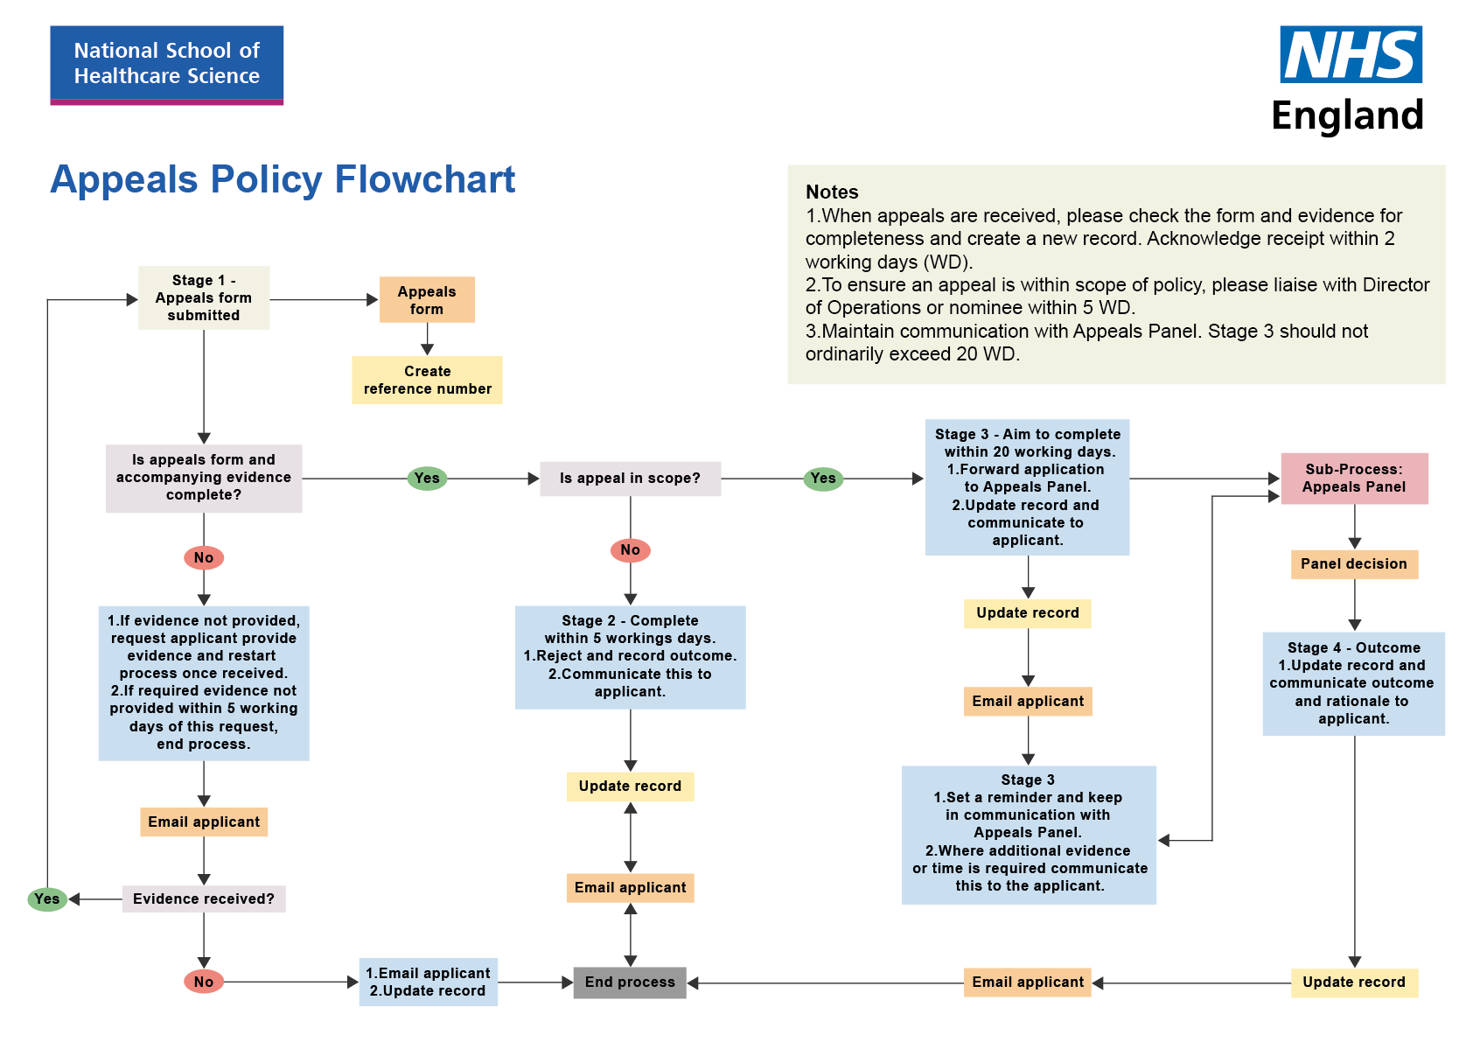

Appendix 2. Appeals form
Name of applicant:
Email Address:
Telephone number:
(Should we need to contact you to discuss the matter)
Date:

Describe in detail the reason for your appeal

Detail any evidence or correspondence that relates to your appeal and attach it. Please ensure attachments are appropriately referenced.

For Office use only.
Reference number:

Any other information:

