Innovation Fellowships for Healthcare Scientists

Application Form:

Please read the Programme Information sheet prior to applying:

DEADLINE FOR SUBMISSION: 7th December 2023
APPLICANT INFORMATION
Surname: |  |  |  |  |  | Title:
Forename(s) in full:

Work Contact Details:  Address including postcode and country (to be used for all correspondence)  Preferred telephone number: |  | E-mail address:
UK Resident:
Yes / No

 |  | Current NHS AfC Band:
Healthcare Science (HCS) Specialism: |  | Date of HCS Qualification:
Job title:  Your de |  | Name of current employing organisation:
Brief outline of relevant qualifications (Max 50 words): |  | Head of Department Contact Details:  Name:  Job Title:  Email:
 |  | Name of Lead contact in Trust Finance Department:
HEALTHCARE SCIENCE INNOVATION FELLOWSHIP: QUESTIONS
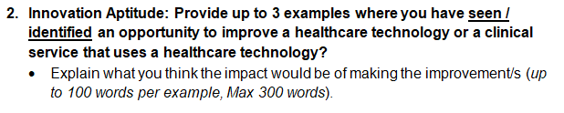
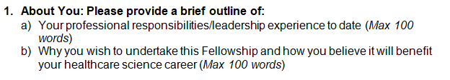
Q2: Innovation Aptitude (up to 100 words per example; Max: 300 words). Please type below:

Q1: About You (Max 200 words)
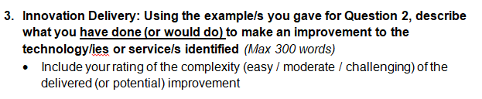
Q3: Innovation Delivery (Max 300 words). Please type below:

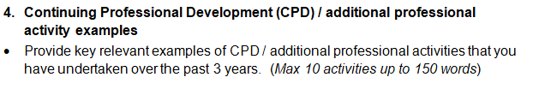
Q4 CPD / Professional Activities. (Max 10 activities up to 150 words). Please type below:

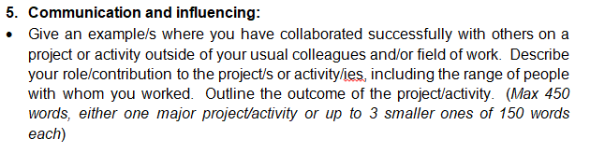
Q5: Communication and influencing (Max 450 words, either one major project/activity or up to 3 smaller ones of 150 words each). Please type below:

6. Project Proposal: (max 600 words)
The focus should be on developing innovative technologies that improves the diagnosis, monitoring and care of patients in addressing issues raised by healthcare inequalities.
Include the following in your proposal:
- Describe the current problem and offer a suggestion for how you might address it.
- Explain the potential benefits and beneficiaries of the proposed project.
- Identify where you believe there are synergies with the NIHR Devices for Dignity clinical themes as outlined in the Background Information.
- Explain why this project is important to you.
- State the tangible project outputs that you would aim to deliver by the end of the 12 month Fellowship period.
- Identify the resources (support, network, collaborations, etc) that you would require to undertake your proposed project.
- Indicate the stage of the technology development for the proposal (e.g. idea, concept, early prototype, functional prototype, evaluation, service redesign to accommodate adoption of a new technology).
- Identify the skills and resources (finding/time/collaborations etc) that you believe would be required to progress the project to completion beyond the 12 month Fellowship period (Max 50 words).
- Would you be willing to modify the proposal or be provided an alternative project, if you are short-listed but your proposed project is not deemed suitable?
Yes / No / Maybe

Q6: Project Proposal: (Max 600 words). Please type below:
Q6: Project Proposal - continuation. Please type below:
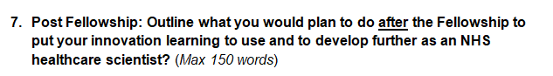
Q7: Post Fellowship (Max 150 words). Please type below:
8. Departmental support:
Provide a short statement of support from your Head of Department (HoD)
(Max 150 words). This should include the following:
a) The relevance of your proposed project to your department/Trust.
b) Confirmation that protected time of an average of 1 working day per week for 12 months will be made available for you to undertake the Fellowship.
c) Confirmation that the duration of your current NHS employment contract covers the duration of the Fellowship e.g. to at least April 2024.
d) Your HoD should note whether consent is given for your proposed project only or whether project selection flexibility is offered. (Final selection would be subject to subsequent agreement with your department)

Declaration of Applicant: | Y/N
I confirm that I have read the Background Information document for the Healthcare Science Innovation Fellows Programme and that I meet its eligibility criteria.
I have completed the application form in full and all information provided is true to the best of my knowledge
Insert Electronic Signature
Declaration of Head of Department: | Y/N
As per my statement of support above, I confirm that I support the Applicant’s submission to the Innovation Fellow’s programme and the required provision of protected time to undertake the programme.
Insert Electronic Signature
Once you have completed this application form, please save it as a PDF using the naming convention: ‘InnovationFellowship_SurnameForename_TrustInitials.pdf’.
Please email the completed pdf version of the form to england.cso@nhs.net with 2023 Healthcare Science in the subject line
ensuring you use ‘HCS Innovation Fellow Application’ in the subject line.

Q8: Head of Department Statement (Max 150 words). Please type below:

