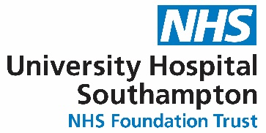
Scientist Training Programme (STP) on-line Open Day

Application Form

Thursday 11th January 2024, 10:30-14:30

From 10:30 General overview (Limited spaces)
Department talks from 13:00
Please complete the information below and email back by 4th January 2024 to:-

hcsahpeducation@uhs.nhs.uk

Personal information
Full name:
Mobile:
Home town/city:
Email:
University:
Programme:
Under or postgraduate:
Please indicate if you would like to attend morning session
(first come first served) Y/N:

These are the areas we are hoping to offer in September 2024 intake.
You have the opportunity to visit 2 departments in the afternoon sessions. Mark with (x)

Audiology |  | Genomic Counselling
Cancer genomics |  | Imaging with non-ionising radiation
Cardiac physiology |  | Nuclear medicine
Clinical biochemistry |  | Radiation safety & diagnostic radiology
Clinical bioinformatics genomics |  | Radiotherapy physics
Clinical immunology

