How to submit a training activity in OneFile

Update
Training activities were previously known as ‘competencies’ and this guide refers to competencies. The process is the same, you will use a submission called ‘training activity’ instead of the ‘competency’ submission type.

1. Login to OneFile at https://login.onefile.co.uk

2. Click on ‘Submissions’ in the left-hand menu bar and then click on ‘Create submission’. See Figure 1.

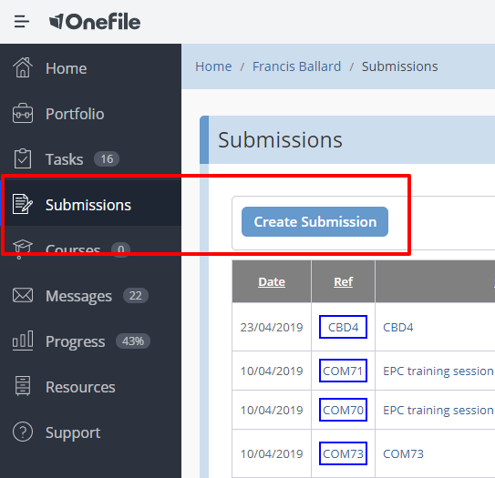

Figure 1 – Creating a submission

3. You will be asked to confirm what type of assessment you are submitting. Select ‘Competency’ from the drop-down list. See Figure 2. After selecting your submission type, you will automatically move to the 'Submission Title' page.

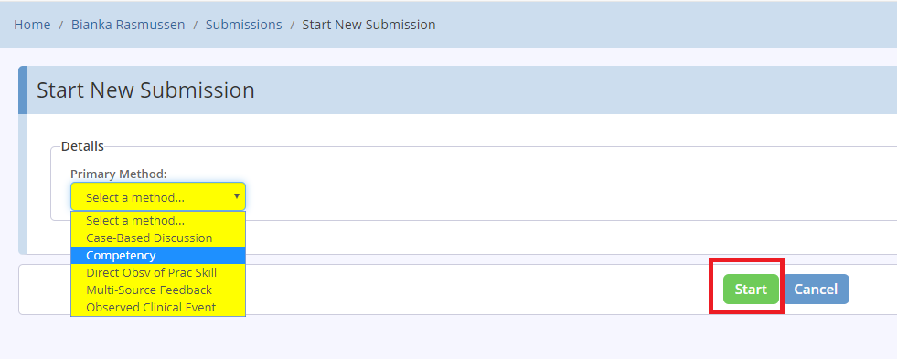

Figure 2 – Select competency as a primary method

4. Enter the title/description of your assessment and click ‘Start’. See Figure 3.

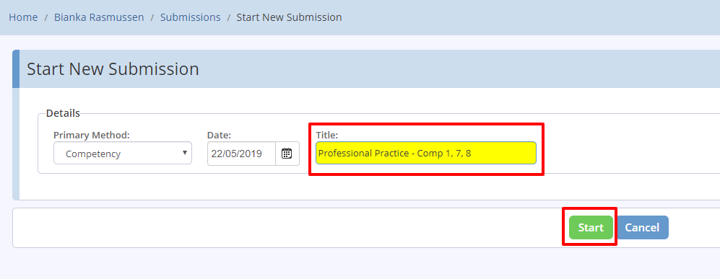

Figure 3 – Enter a submission title

5. Next select the competency or competencies that you are submitting evidence for. To do this click the ‘Set Criteria’ button under ‘Competencies & Standards’. See Figure 4.

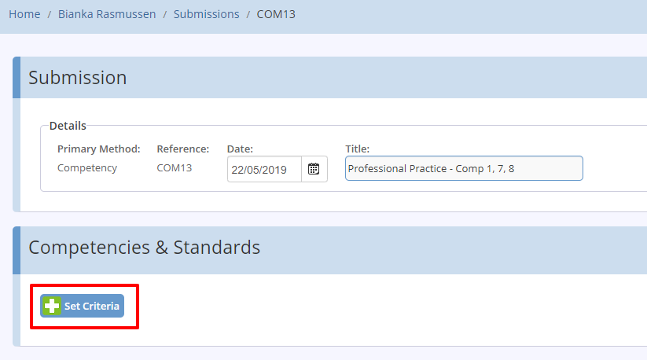

Figure 4 – Click on set criteria

6. On the next screen you can view your current progress using a 'Gap Analysis' view or a 'Tree View'. We recommend selecting the gap analysis view. Expand the module in which you are working and tick the box next to the competency/competencies towards which you are submitting evidence.

Please only select competencies at this stage. Do not select assessments such as CBDs, DOPS, OCEs or MSFs. Each of these must be submitted independently and not as part of a competency submission. After you have selected the competencies, click the ‘Back’ button. See Figure 5. You will then return to the main submission screen.

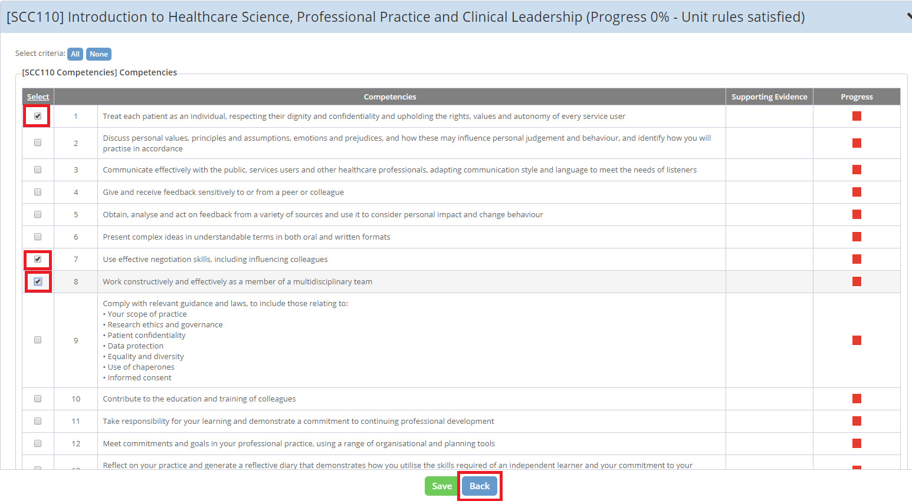

Figure 5 – Selecting the competencies

7. The competencies you selected on the previous page will now appear in light blue under ‘Competencies & Standards’. If you need to amend this selection, simply click ‘Set Criteria’ again. See Figure 6.

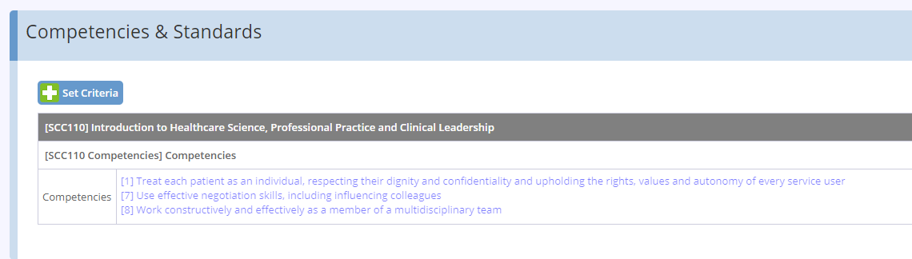

Figure 6 – The set criteria option

8. Enter some details and narrative about your evidence in the free text evidence section and attach any documents you wish to upload as evidence. If your assessor is new to OneFile we recommend attaching to your submission guidance on how to respond to a submission which is available on the School website.

How to respond to a submission in OneFile

We also recommend attaching a link to the specific competency you are submitting evidence for in the School's Curriculum Library. This will give your assessor a full understanding of the Knowledge and Understanding required to fulfil the competency.

9. Once you have added your evidence, review your submission to ensure you have added all your evidence and selected the correct competencies. Figure 7 shows you a submission ready to be submitted.

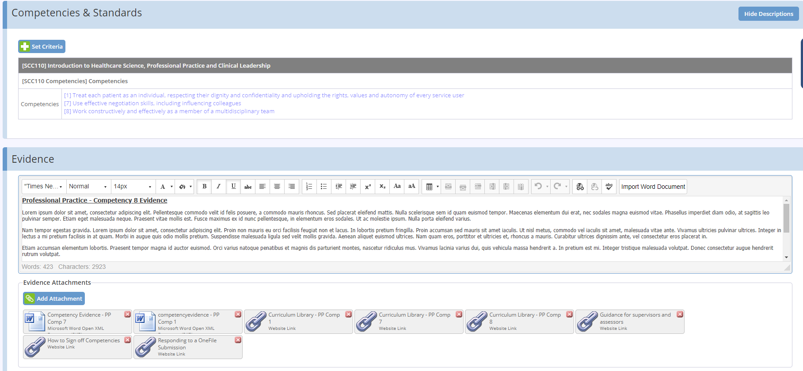

Figure 7 – An example submission

10. Once you are satisfied with the quality and content of your submission, scroll to the bottom of the page and tick the box highlighted in yellow. See Figure 8. This will indicate you are now submitting your assessment for review.

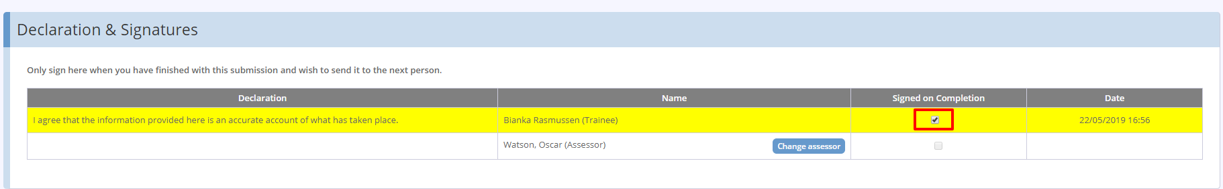

Figure 8 – Declaration and signature option

11. By default, your Training Officer will show as the assessor. If you want to change your assessor, click the ‘Change Assessor’ button. If your chosen assessor is not listed in the drop-down list then you should nominate your chosen assessor by clicking on the ‘Invite New Assessor’ link in the drop-down menu. See Figure 9.

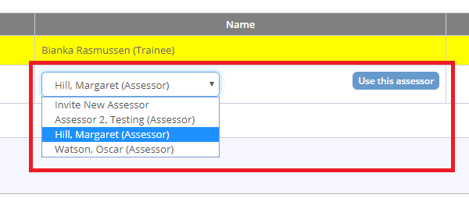

Figure 9 – Choosing an assessor

12. After selecting your assessor and ticking the signature box, click ‘Save & Quit’ to formally submit your assessment to the assessor. See Figure 10.

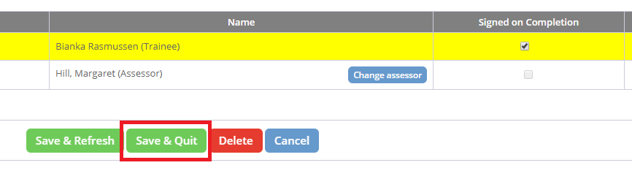

Figure 10 – Save and quit option

