How to submit an in-person work-based assessment

Guidance on submitting DOPS, OCEs or CBDs

When you and your Training Officer have agreed that you will perform an observed assessment, such as a DOPS, OCE or CBD, we recommend that you send a submission for that assessment to your assessor before the event. Also attach the appropriate work-based assessment feedback form to the submission.

Blank copies of the work-based assessment feedback forms can be download from OneFile via the ‘Resources’ link in the left-hand menu. Click on ‘Resources’ then ‘STP Trainee Resources’ then ‘Assessment Feedback Forms’.

If you wish to submit additional evidence to your assessor about the DOPS, OCE or CBD, such as a video or audio recording from the event, then we recommend that you make this submission after the event.

Step-by-step guide to submitting a workplace-based assessment

- Login to OneFile at https://login.onefile.co.uk
- Once logged in, click ‘Submissions’ in the left-hand menu bar, and then click on ‘Create Submission’. See Figure 1.

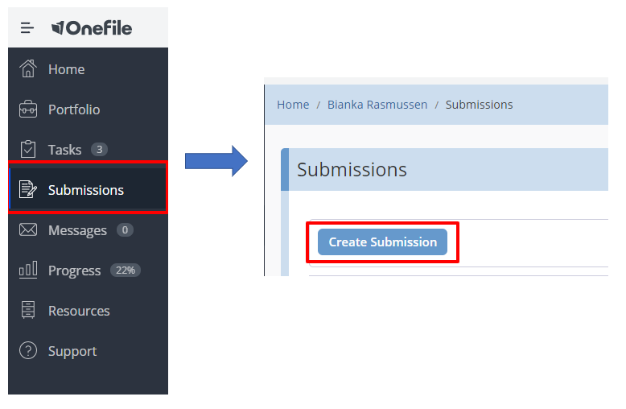
Figure 1 - Submissions

- In OneFile's 'Primary Method' drop-down list, you need to confirm what type of assessment you are submitting. See Figure 2. It is very important that you select the type of assessment that your submission relates to. If you are submitting a DOPS, OCE or CBD you must not select 'Competency' or 'Multi-Source Feedback' from this list. After selecting your assessment type click 'Start'.

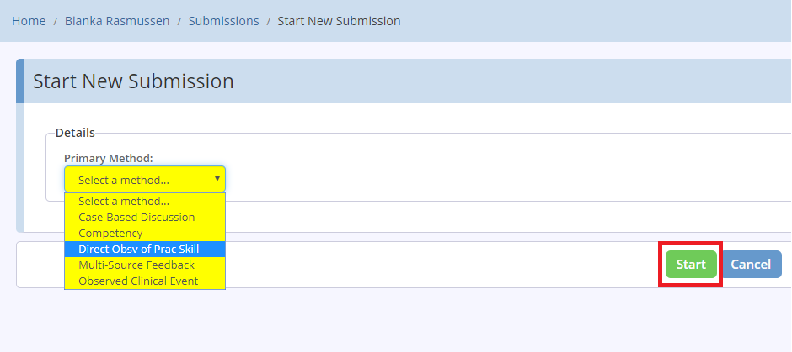
Figure 2 – Primary Method selection options

- Next, enter a title or description for your assessment and then click ‘Start’. See Figure 3.

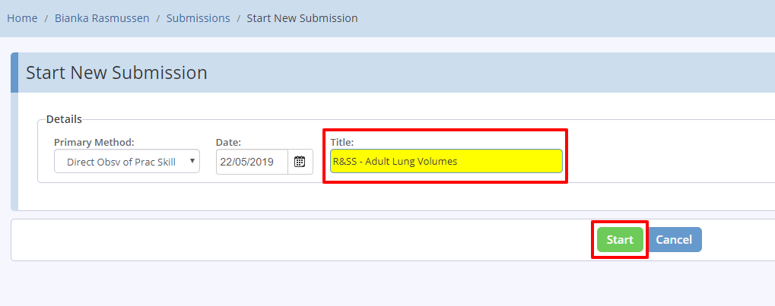
Figure 3 – Enter title of submission

- Now you need to select the specific assessment that you are making this submission for. To do this click ‘Set Criteria’ under ‘Competencies & Standards’. See Figure 4.

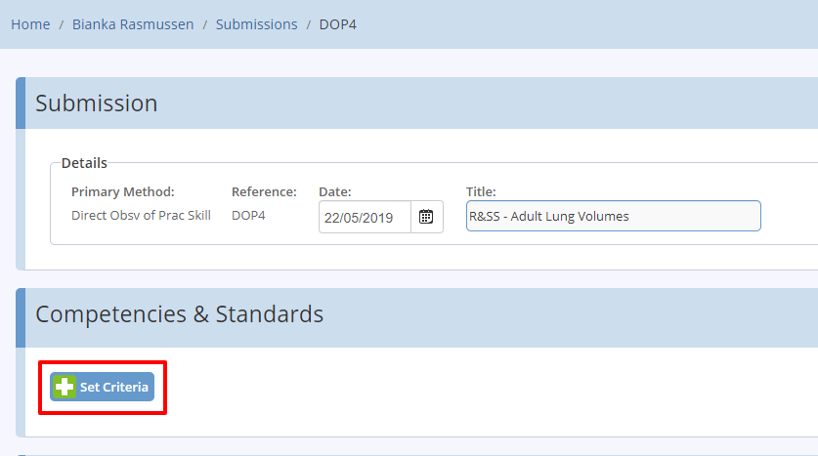
Figure 4 – Competencies and Standards

- On the next screen you are presented with a list of all your modules. OneFile presents this as a 'Gap Analysis' view or a 'Tree' view. We recommend using the gap analysis view. Click on the module containing the specific assessment you wish to submit and then tick the box next to the specific assessment itself. When submitting workplace-based assessments you must only select one per submission i.e., do not request your assessor to sign off multiple DOPS/OCEs within one submission. After you have selected the specific assessment, click on the ‘Back’ button. See Figure 5.

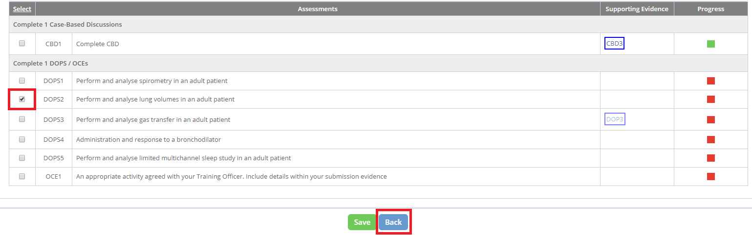
Figure 5 – Gap Analysis view of modules

- You should notice that the assessment or criteria you selected on the previous page now appears in light blue under ‘Competencies and Standards’. If you need to amend this selection, click on ‘Set Criteria’ again. See Figure 6.

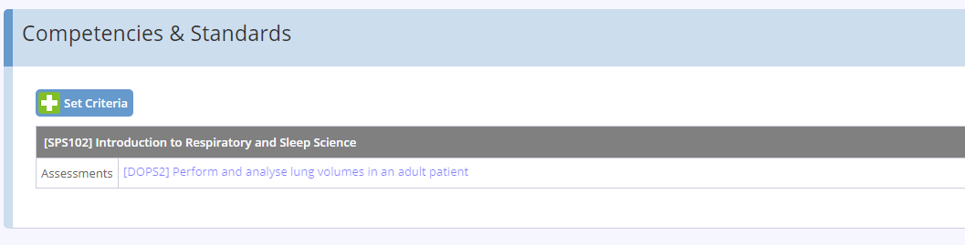
Figure 6 – Set criteria
- Now you should also attach a blank workplace-based assessment feedback form, so that your assessor can provide as much feedback as possible. Blank copies of the forms can be found in OneFile under Resources > STP Trainee Resources > Assessment Feedback Forms.
- If you have any evidence to submit towards this assessment e.g., a video recording of your practical skill, you can submit it as an attachment. Additionally you can supply some free text narrative in the free text evidence box.
- We strongly recommend that you attach the guidance for assessors on signing off workplace assessments, which is available on the School's website.

How to sign off observational assessments in OneFile
How to respond to a submission in OneFile

- Review your submission to ensure you have added the appropriate attachments and selected the correct assessment that you wish to be signed off. Figure 7 shows a submission ready to be submitted.

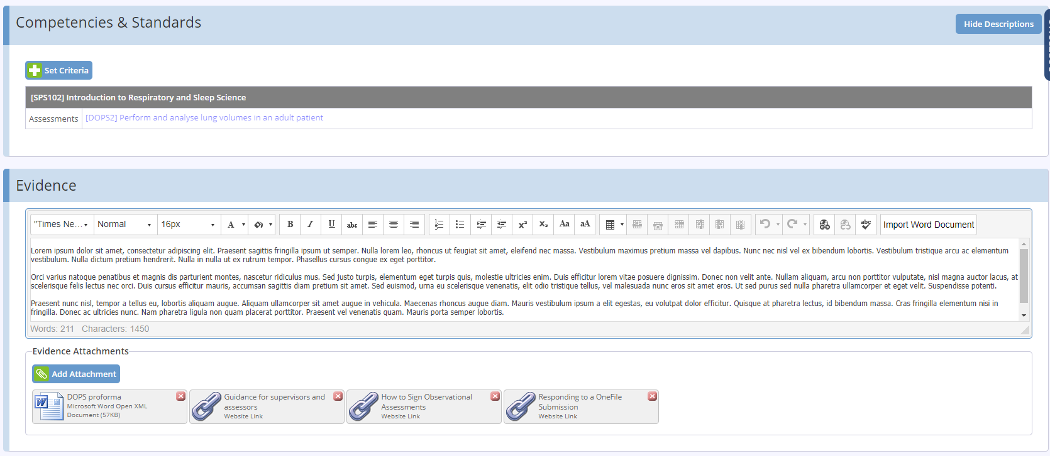
Figure 7 – Submission example

- Once you are satisfied with your submission, scroll to the bottom of the page and tick the signature box highlighted in yellow. This will indicate you are now submitting your assessment for review. See Figure 8.

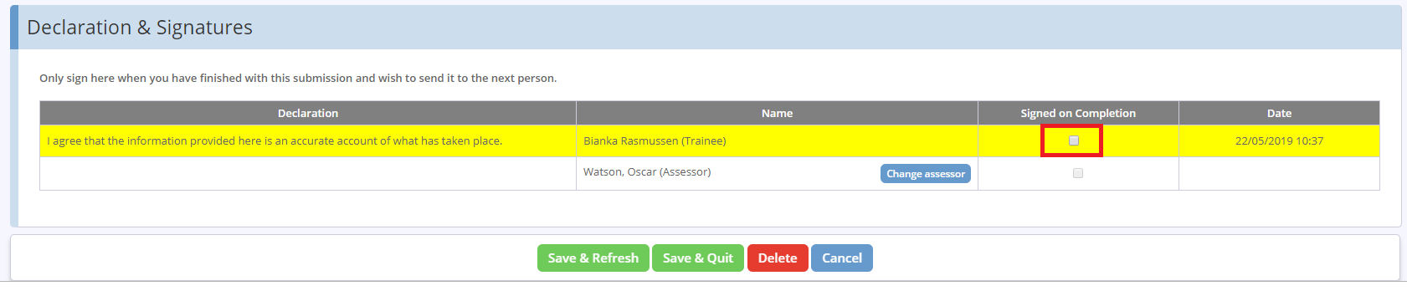
Figure 8 – Signature box

- By default, your Training Officer will show as the assessor. If you want to change your assessor, click the ‘Change Assessor’ button. If your preferred assessor is not listed, you can nominate your chosen assessor at this point. If you do select a new assessor you must click ‘Use this assessor’ to save that assessor for this submission. See Figure 9.

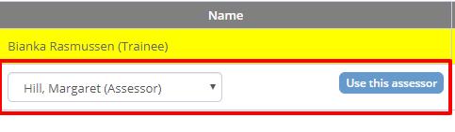
Figure 9 – Choosing an assessor

- Click ‘Save & Quit’ to formally submit your assessment to the assessor. See Figure 10.

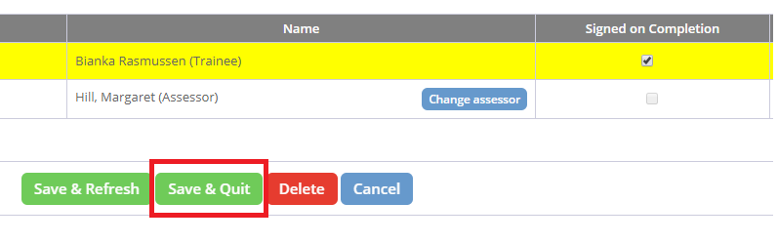
Figure 10 – Save and quit option

