How to unlock a submission in OneFile

After a trainee has made a submission for assessment, it may need to be amended or sent to another assessor. This can be done by Training Officers who are also known as ‘default assessors’ in OneFile. Submissions can be unlocked:
- back to trainees so they can make amendments to them
- to different assessors associated with the trainee so that the correct person can assess the submission
- back to Training Officers/Supervisors, so that they can provide feedback on them.

Follow these steps to unlock a trainee’s submission

1. Login to OneFile at https://login.onefile.co.uk/

2. From within the ‘Trainee Dashboard’ on your OneFile homepage, click on the trainee’s name to go to their portfolio. See Figure 1.

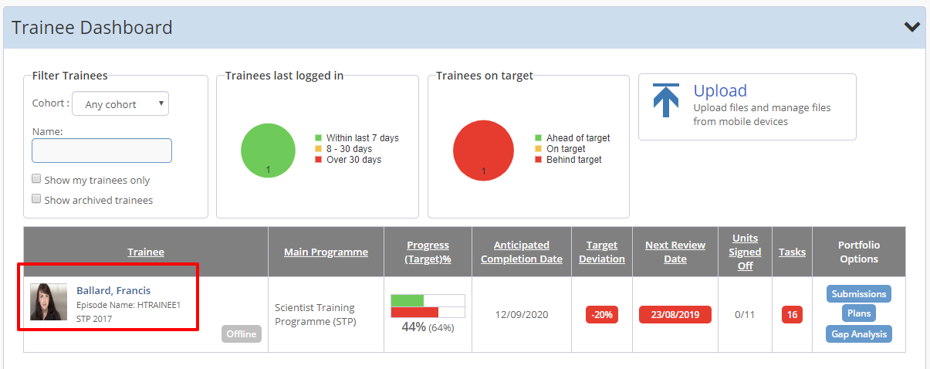
Figure 1 – Selecting a trainee

3. To access a list of the trainee’s submissions, click the ‘Pending’ tile on the trainee’s portfolio landing page. See Figure 2.

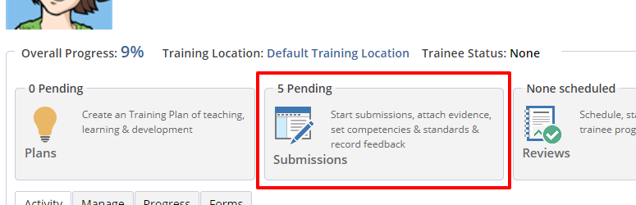
Figure 2 – Access the submissions list

4. You will now be presented with a list of the trainee’s pending submissions. On this page you can also filter the list using the drop-down menu at the top right of the list. This will enable you to see ‘Completed’ or ‘Pending’ submissions. See Figure 3.

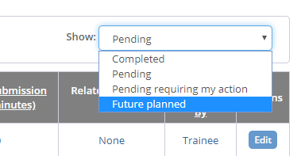

Figure 3 – Using the pending filter option

5. When you find the submission that you wish to unlock, click on the blue box relating to that submission to open it. See Figure 4.

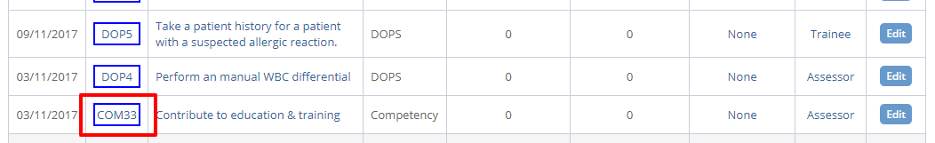

Figure 4 – Unlocking a submission

6. Once the submission is open click on the padlock symbol in the top right-hand corner. See Figure 5.

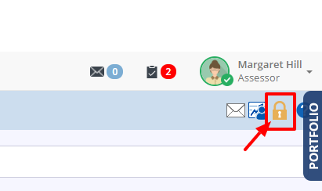

Figure 5 – Click the padlock symbol

7. You will then see a list of the people that the submission can be unlocked to. See Figure 6.

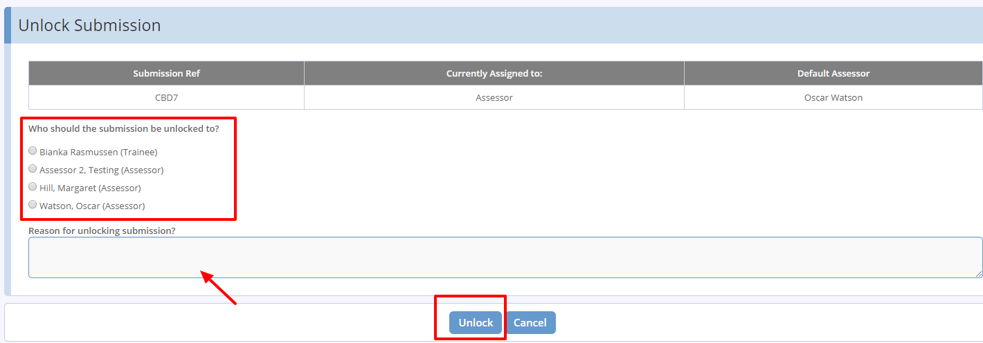

Figure 6 – Choose who to send the submission to

8. Click the check box beside the name of the person you wish to send the submission to. You need to supply a brief reason for unlocking the submission, otherwise the system will not allow you to proceed. The unlock button can then be selected and the unlocked submission should appear in the relevant individual’s task list to action.

